
Company
Logotype

Cone Beam Computed Tomography- Report



Porur Dental X-rays & CBCT

Patient Name : Mr. Mugunth | Date of Report : 07.04.2024
Age/ Gender : 13 years/ Male | Region of Interest : CBCT Sectional Mandible
Referring doctor: Dr. Sindhuja | Indication : Impacted tooth
Clinical Notes: Nil
PATIENT INFORMATION

CBCT Sectional Mandible provided
CBCT – IMAGE DETAILS

RADIOGRAPHIC INTERPRETATION

- The tooth 43 appears to be within the alveolar bone obliquely placed within the alveolar bone with its crown positioned anteriorly below the periapical aspect of 41, 42 and its root positioned posteriorly.
- The labial aspect of the crown of the impacted 43 in present involving the labial cortical bone causing areas of discontinuity and the root of 43 is at a distance of 2.44 mm from the lingual cortical bone.
- The lingual aspect of 43 lies in close proximity to the root of 42.
- Distance between the alveolar ridge and 43: 2.5 mm
- Distance between the mental foramen and 43: 11.33 mm
- Distance between the lower border of mandible and 43: 9.62 mm

RADIOGRAPHIC IMPRESSION


- Impacted tooth: 43.

IMAGES FOR REFERENCE

RECONSTRUCTED PANORAMA VIEW
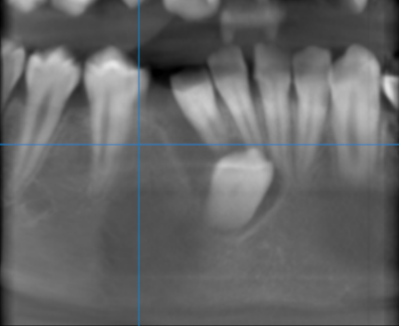

3-DIMENSIONAL VIEW

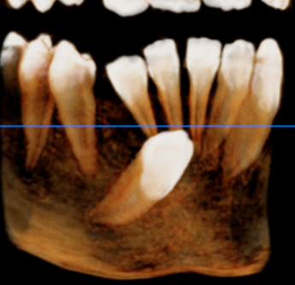

43 REGION | 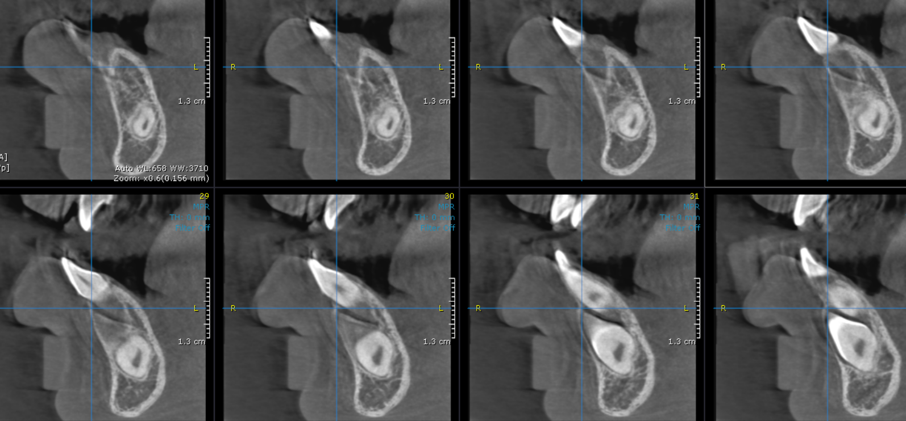

CROSS- SECTIONAL IMAGES

**** End of report ****

